The sea and our weather

Part 1: Thermographs
- What is a thermograph?

- What can you find out from a thermograph?
- What do the colours mean?
- View the thermograph below and then answer the questions.
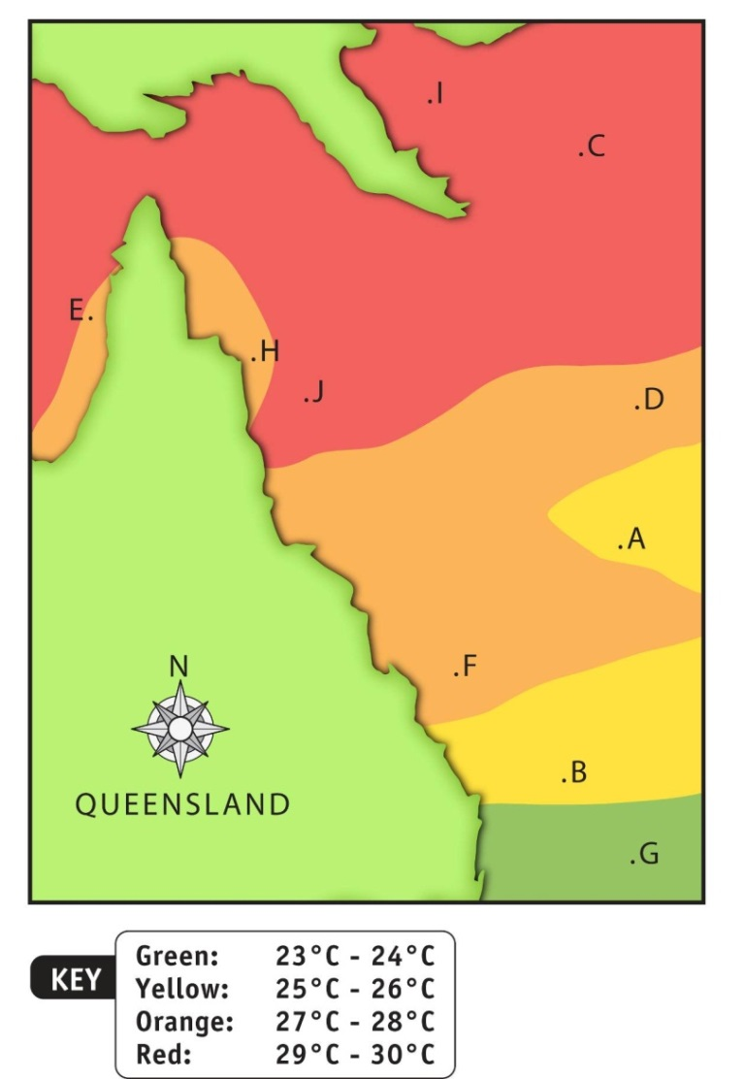
- Each letter on the map represents a different location. What is the temperature at each location?
A |  | B |  | C |  | D |  | E
F |  | G |  | H |  | I |  | J

Part 2: Drawing thermographs
- Use the key to colour the map below to make a thermograph.

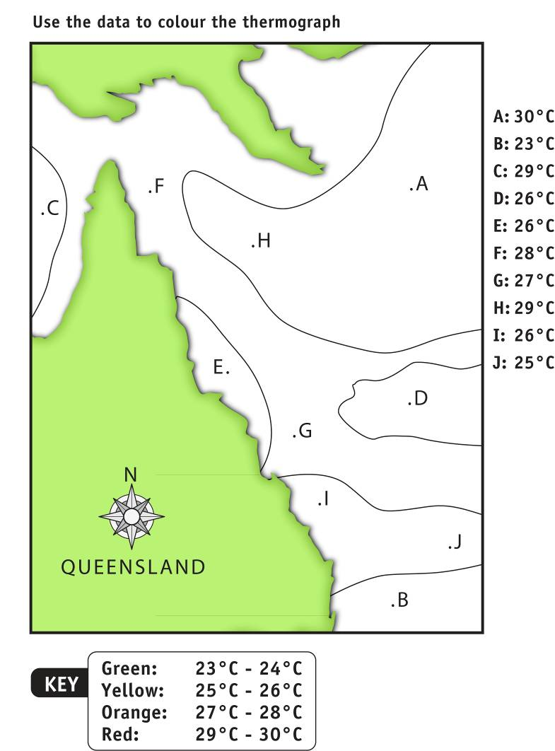

- Explain why you think temperatures change from north to south.

- The average land daytime temperature near Point B during summer is 32 °C. Would there be an onshore or an offshore breeze during the day.

- Tropical cyclones can only form when the sea surface temperature is above 26.5 ˚C. Mark an X on the map at any point where it might be possible for a tropical cyclone to form.

- Explain how thermographs may assist in making more accurate weather predictions.

